**SECTION 2 INSTALLING AND CONNECTING TO A LINUX SYSTEM**

LINUX DISTRIBUTIONS

Linux distribution

* A collection of software and applications, together with the linux kernel, that work well together, forming an operating system that can be customizable
* Every linux distribution has in common the linux kernel, which is the intermediary between the software and the hardware, yet the applications that each distributions may have may be different.
* The two most popular linux distributions are red hat (CentOS is the free version of red hat since it is ultimately red hat, but without the branding/logos) and Ubuntu

GETTING CONNECTED

Connecting directly (when you have physical access or if the linux system is running on a virtual machine)

* Use the GUI or the command line

Connecting over the network

ssh

* It means secure shell
* It is a network protocol
* Allows you to connect from one system to another, over a network, securely
* Use puTTY as your ssh client in windows
* Use the terminal in mac (ssh <ip address/servername>)

**SECTION 3: LINUX FUNDAMENTALS**

LINUX DIRECTORY STRUCTURE

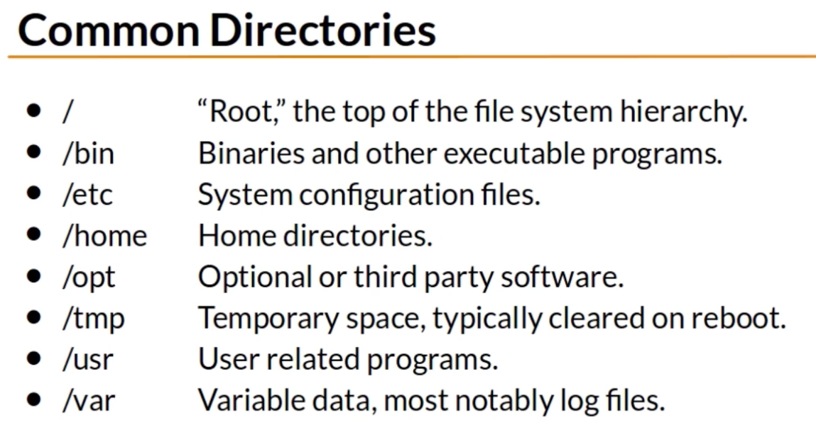

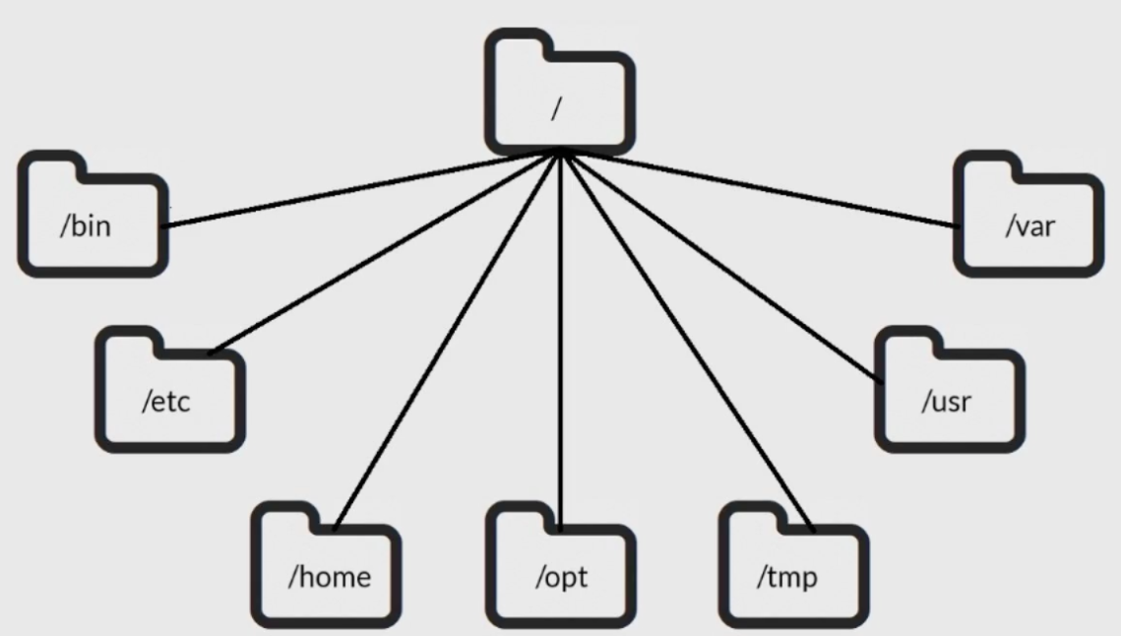

Common directories

* Bin directory: is where all the compressed files for programs is located. Called binaries because the files are machine code
* etc directory: control how the operating system or applications behave
* home: where you can separate your data from other users data within linux environment
* Opt: programs that are not part of linux OS (EX: google maps)

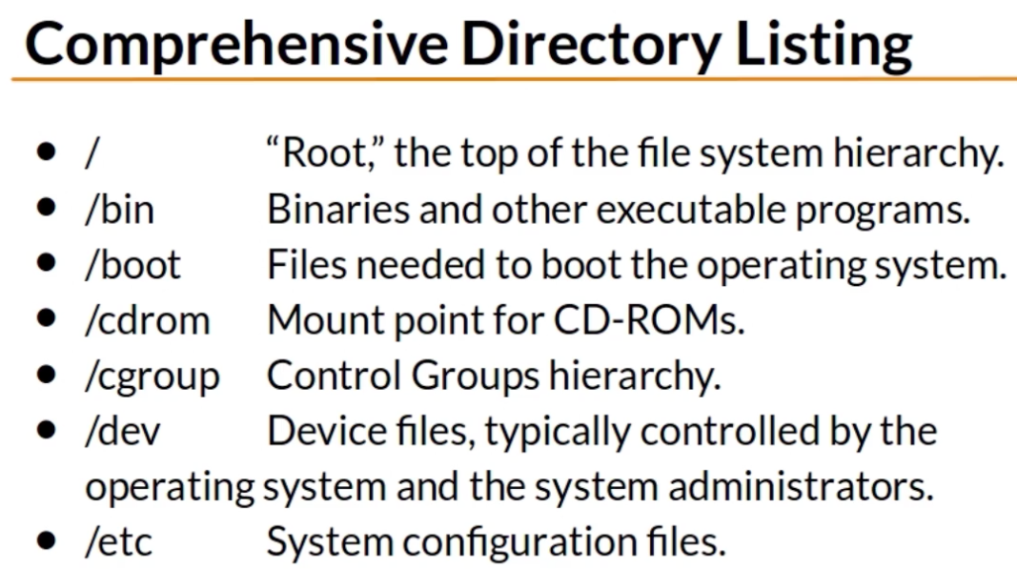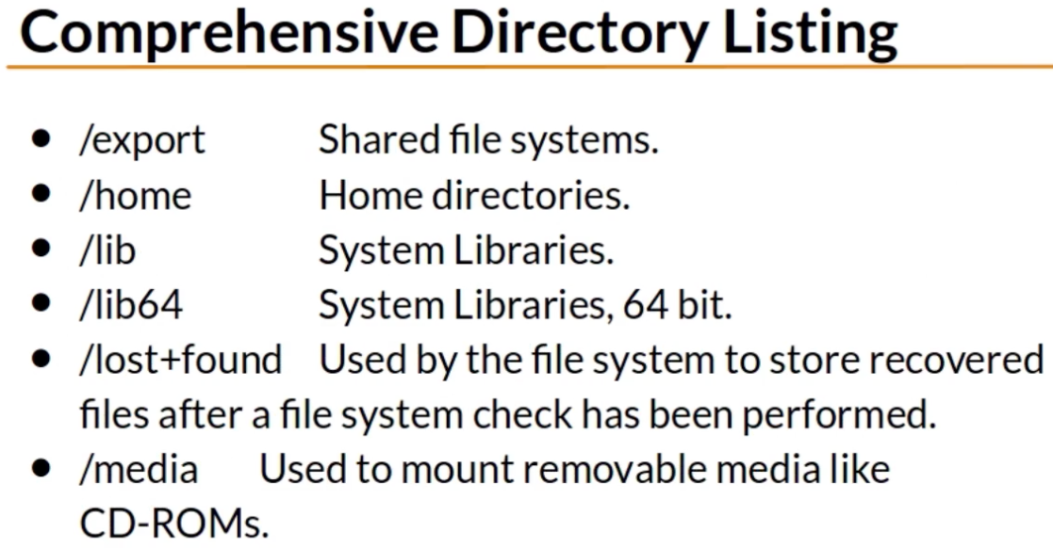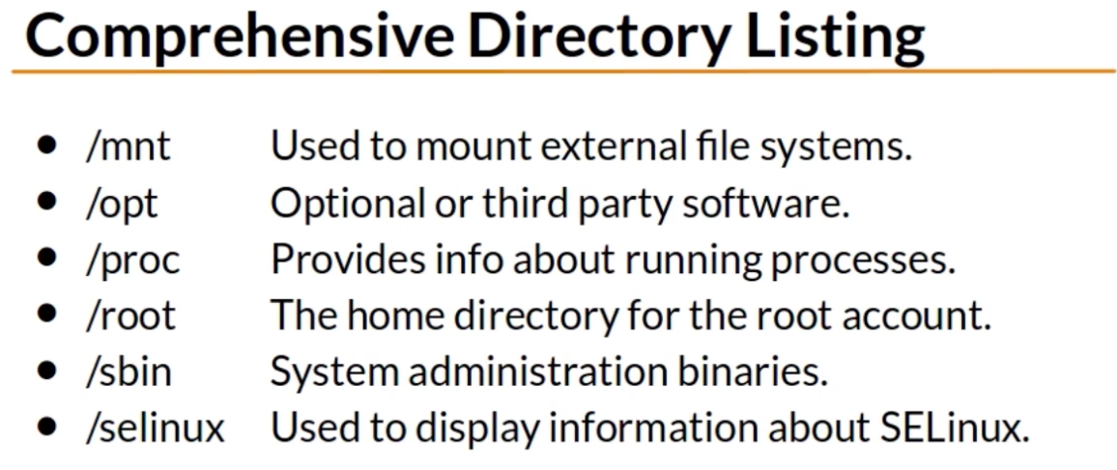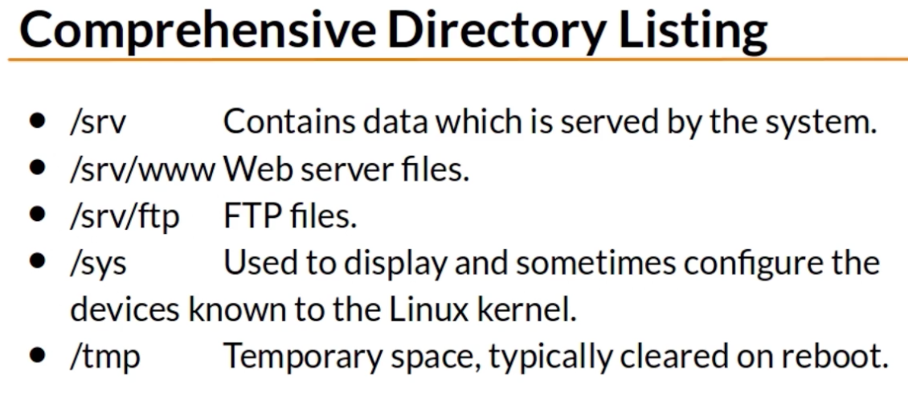

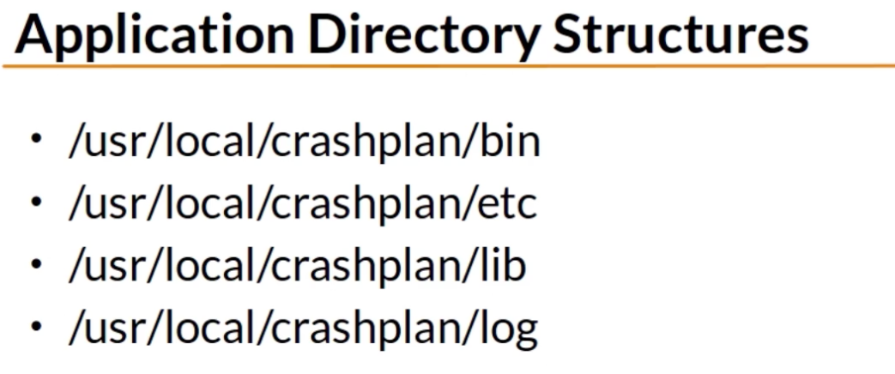

Commonly used as

* /usr/local/<programName>/…
* /opt/<applicationName>/…

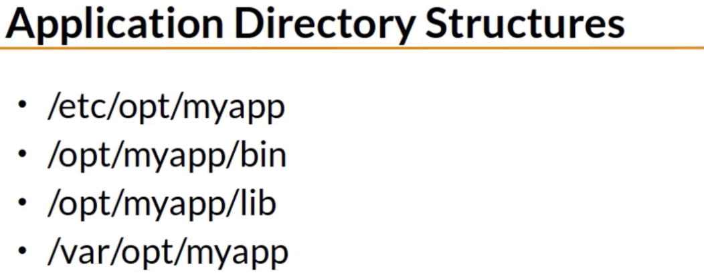

Sometimes applications may have been installed following the /opt/<applicationName>, yet it may have also installed configuration files in etc/opt/<applicationName> and log files in /var/opt/<applicationName>

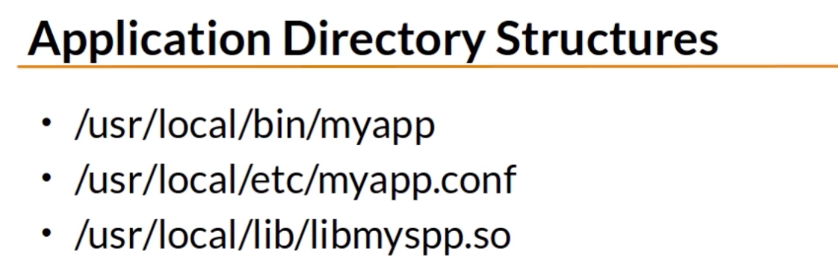

Sometimes applications are not given their own directory structure, but are installed in a shared manner

* for example, /usr/local/bin/ will have a lot of program binaries, one of them could be named “myapp”

Summary:

* Applications that are not part of the base OS can be installed in /usr/local or /opt

THE SHELL

When talking about the shell we are referring to the command line interface, a program that waits for commands to be executed

Normal user vs superUser (root user)

* A normal user is identified by the username and the linux system to which it is connected, and the prompt command ends with a dollar sign ($)
* A superUser is identified by the root keyword and the linux system to which it is connected, and the prompt command ends with a hash symbol (#)
* When talking about root, it can mean two things. First, the root directory. Second, the superUser account

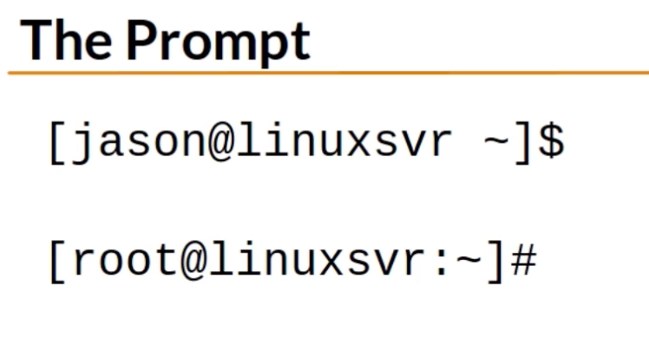

You may need root access to start, stop, and install several applications

The tilde represents a home directory; it can be your home’s directory, another user’s home directory or even a service home’s directory

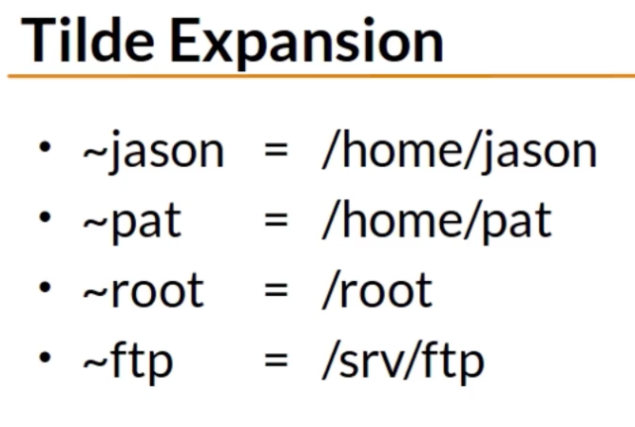

BASIC LINUX COMMANDS

echo is used to display the values of variables (ex: environment variables)

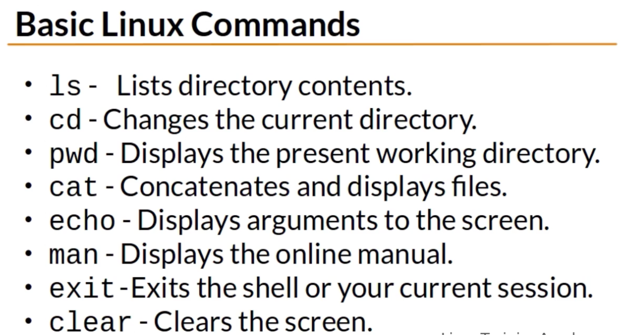

GETTING HELP AT THE COMMAND LINE

Environmental variables

* Storage locations that have a name value pair
* Typically uppercase
* Access the contents by using= echo $VARNAME

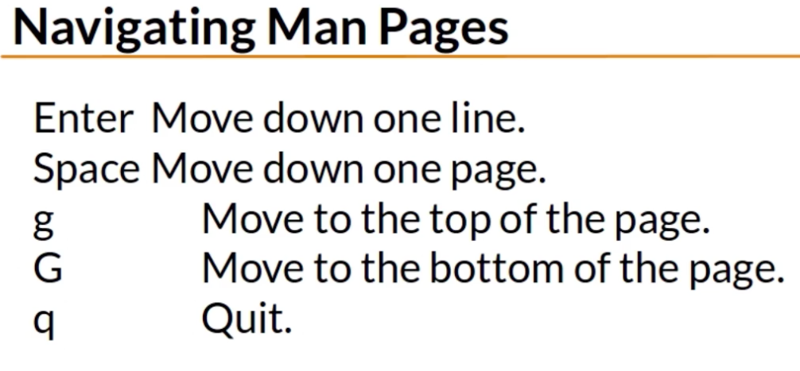

PATH

* Is an environment variable
* Controls the command search path (when you type a command at the prompt, that command will be searched for in the directories that are listed in your PATH environment variable)
* It determines where the shell will look for commands
* Contains a list of directories separated by a colon

If you want to know the location or the full path of the command that you are executing use the “which” command

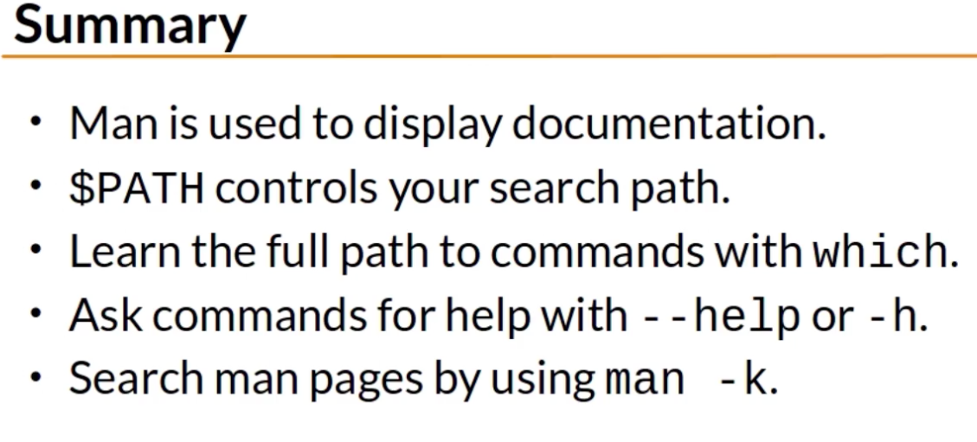

WORKING WITH DIRECTORIES

$OLDPWD

* Environment variable that holds the directory you were previously in

rmdir command only deletes empty directories

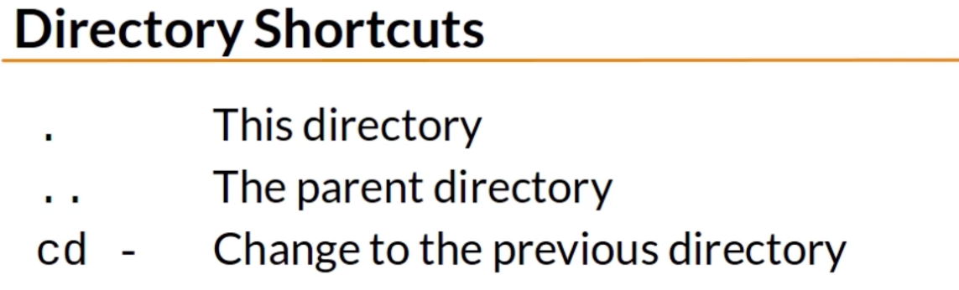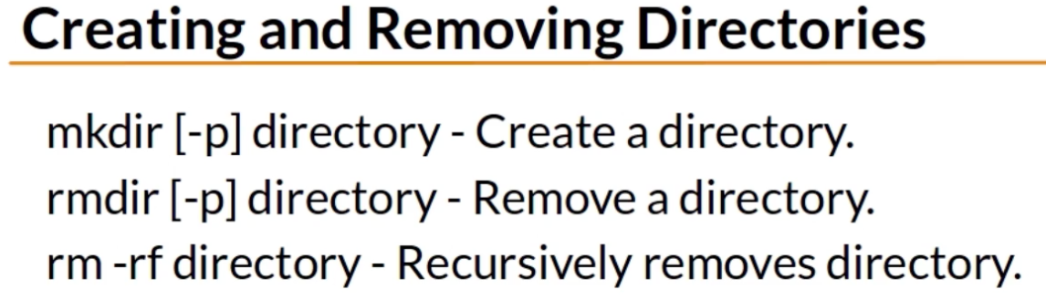

LISTING FILES AND UNDERSTANDING LS OUTPUT

Hidden files begin with a period; they are not shown by default. If you want to show them use the command “ ls -a”

* Shortcut tip: after the – in a command you can specify all options you want, for example “ ls –l –a ”

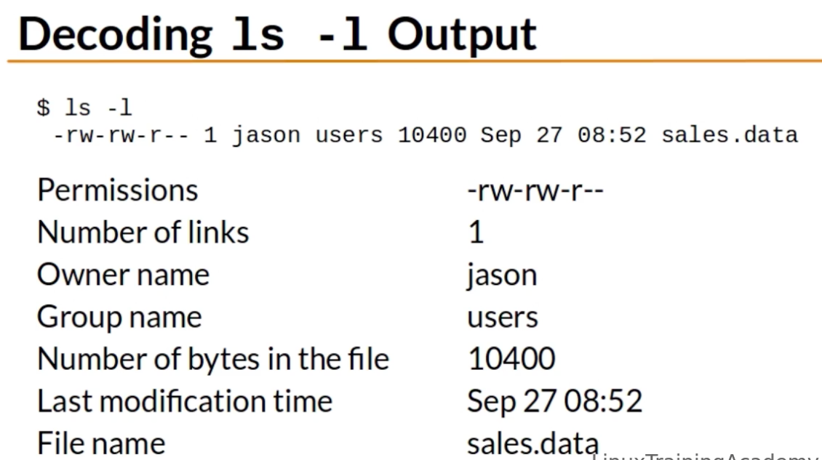

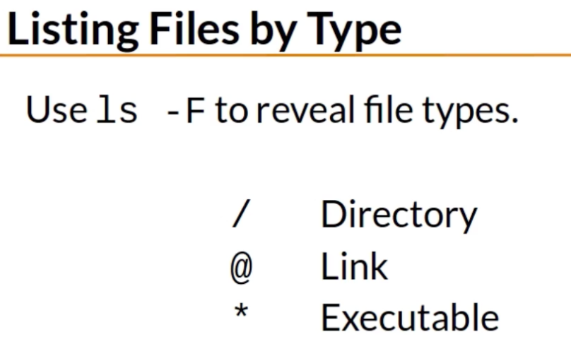

Symbolic links

* A link is a pointer to the actual file or directory
* Use the link as if it were the actual file or directory
* A link can be used to create a shortcut (shortcut for long file/directory names or to indicate the current version of a software)

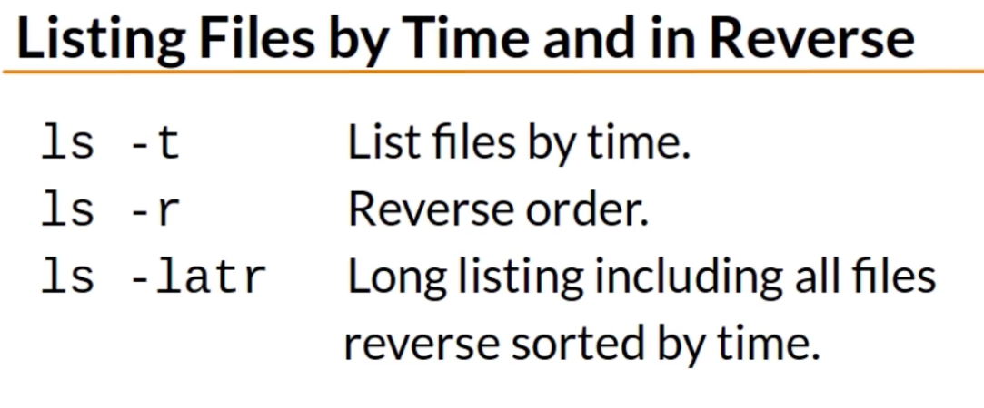

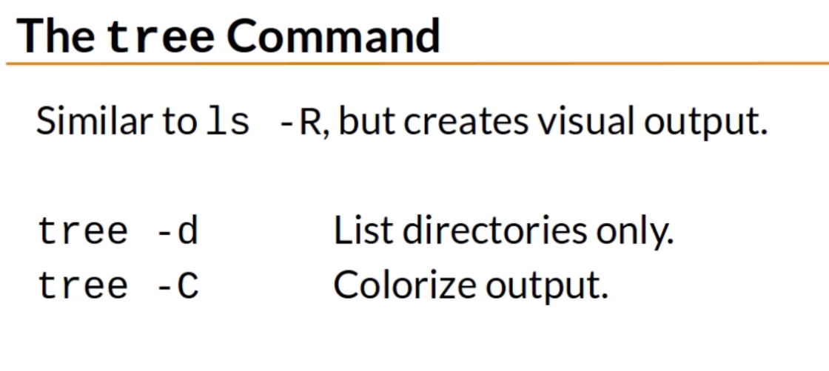

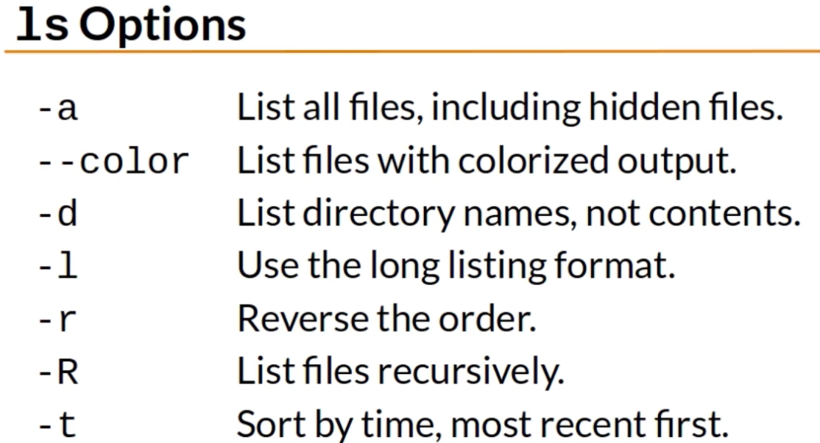

FILES AND DIRECTORY PERMISSIONS EXPLAINED PART ONE

Every user is in at least one group (the primary group), yet it can be in many groups

* The groups command displays a user’s group

Permissions are also known as modes, that is why the command used to change permissions is “chmod”

* You can change permissions using symbolic mode or numeric mode

The first character in the ls –l output represents the type

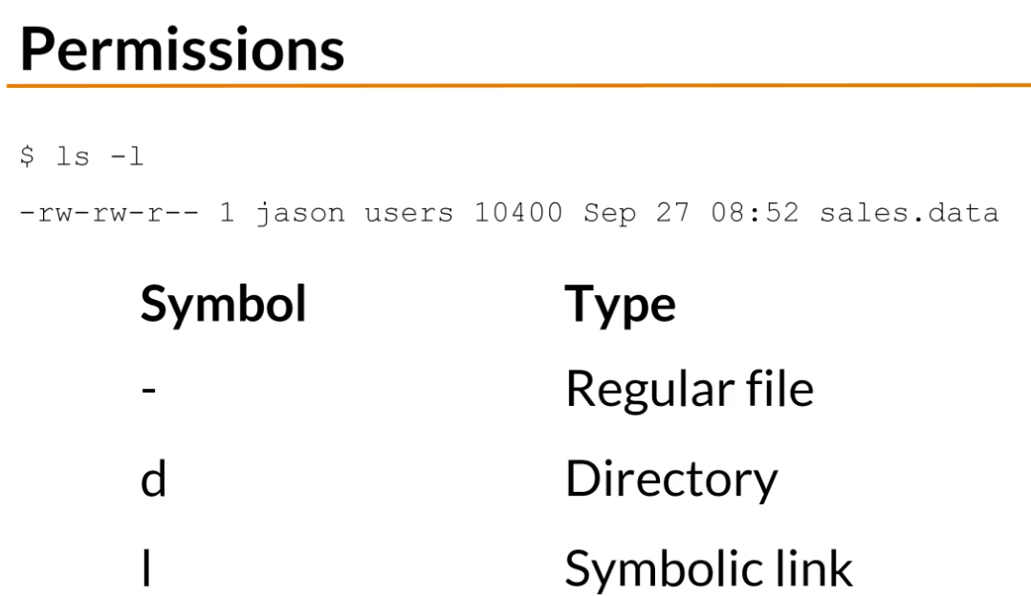

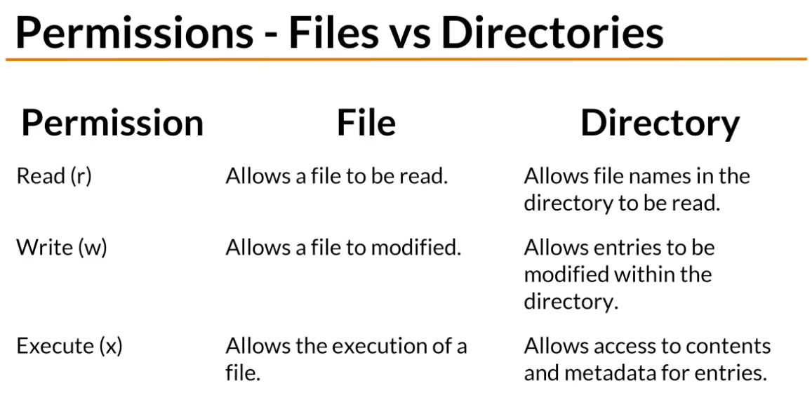

the u represents the user that owns the file

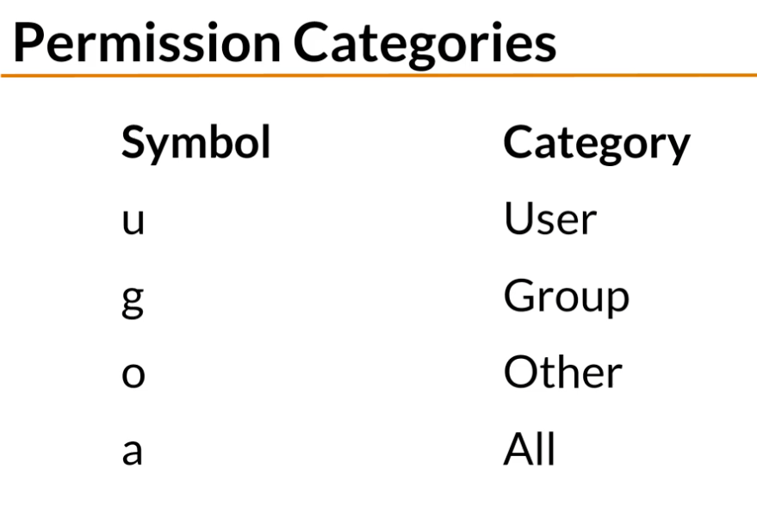

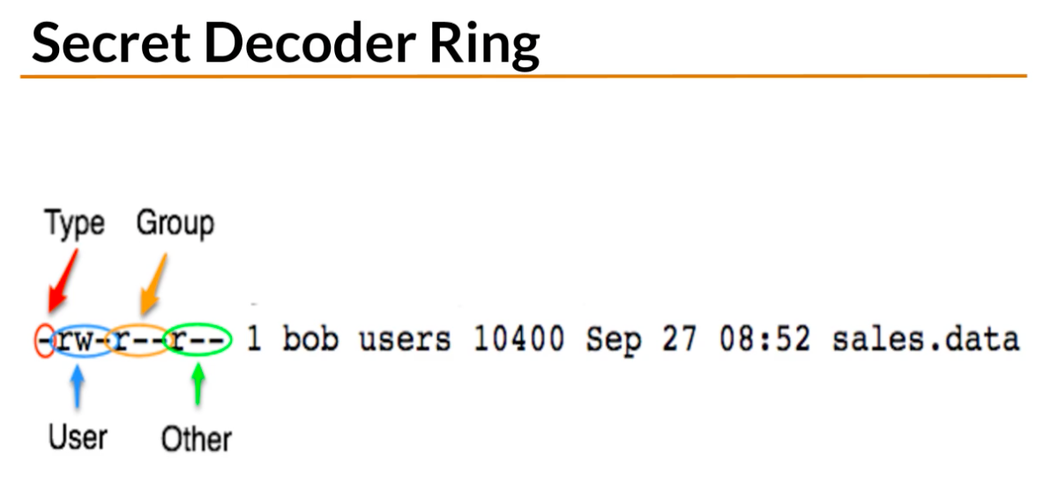

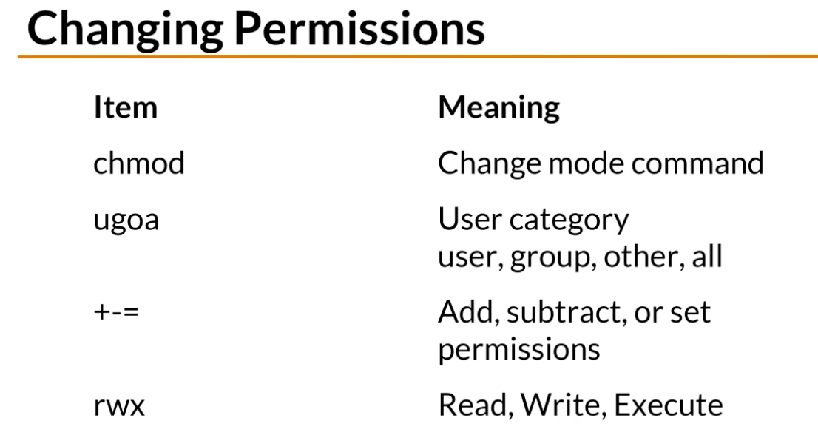

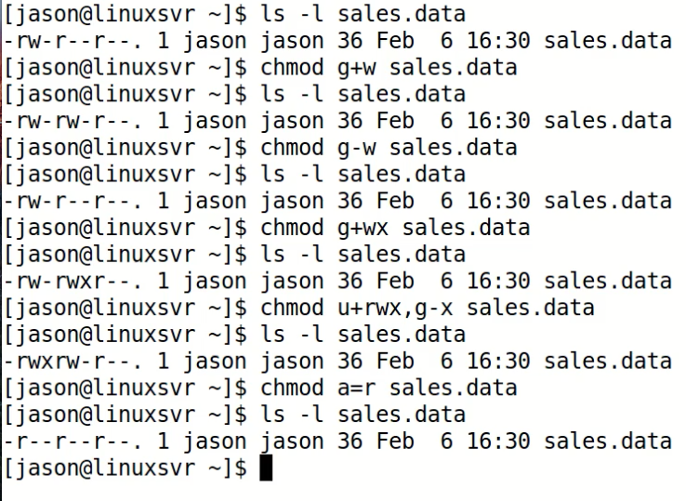

FILES AND DIRECTORY PERMISSIONS EXPLAINED PART TWO

New files that you create belong to your primary or first group

* The “ chrgrp ” command changes the group

Directory permissions

* Permissions on a directory can affect the files in the directory
* If the file permissions look correct, start checking directory permissions to see if there is a contradiction, and work your way up from here, check the permissions on the father directory of the directory that contains the file, and so on.

Summary

* Permissions can be represented by symbols (+-=) or numbers

FINDING FILES AND DIRECTORIES

Find

* Searches for files in real time

Locate

* Can be faster than find, but it is not in real time, it has a small lag since it need to update the indexes

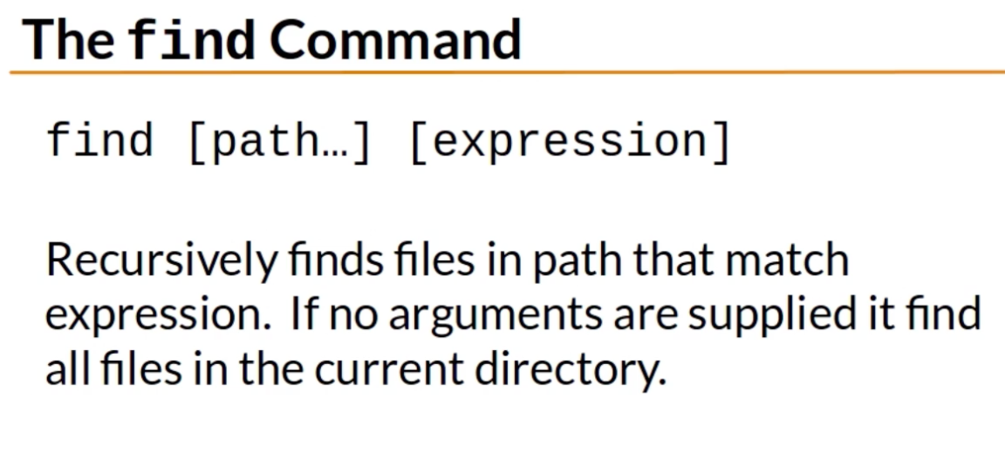

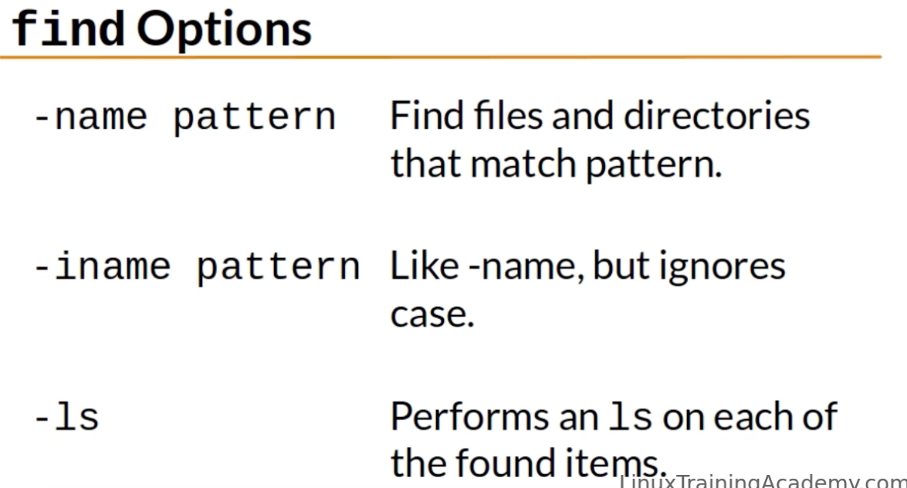

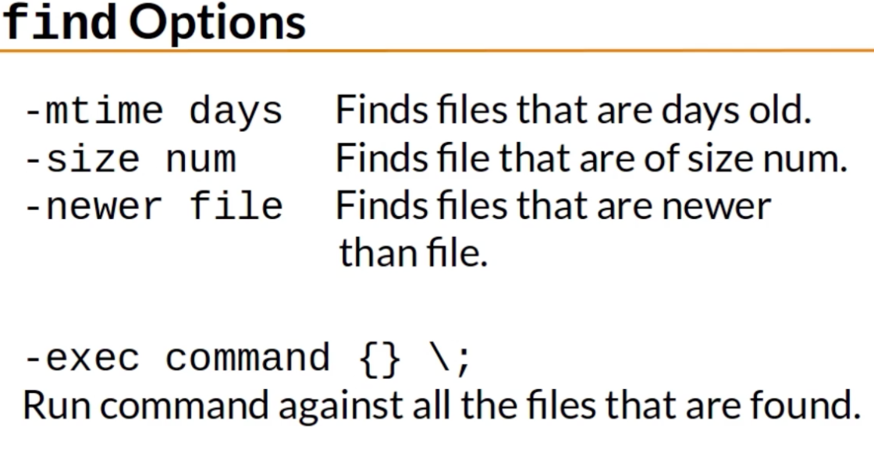

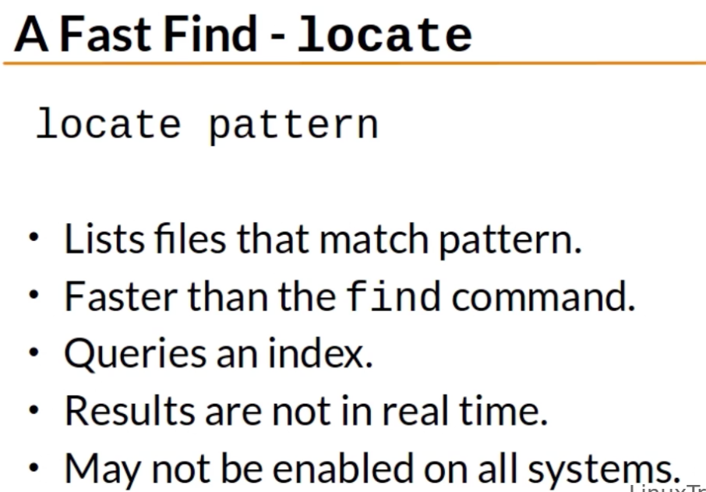

VIEWING FILES AND THE NANO EDITOR

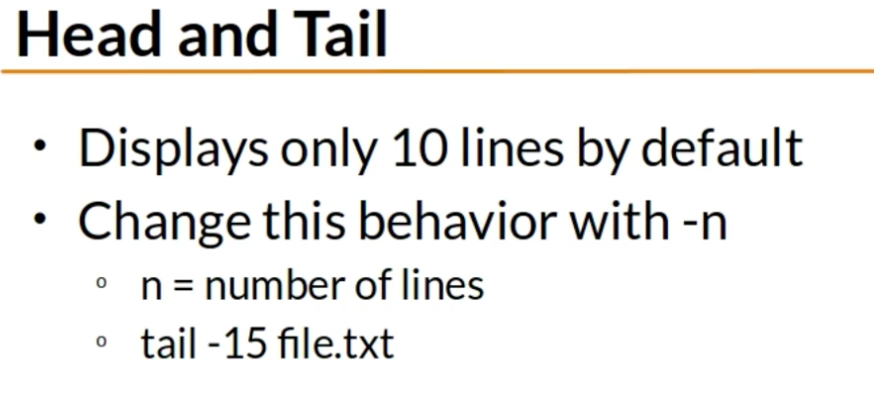

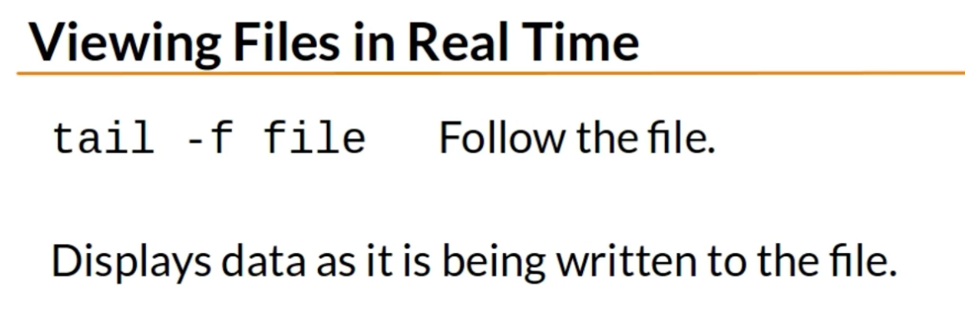

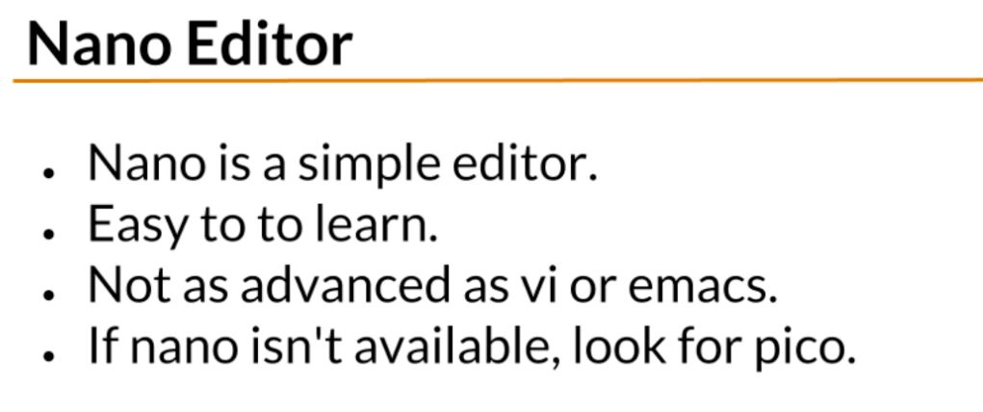

DELETING, COPYING, MOVING, AND RENAMING FILES

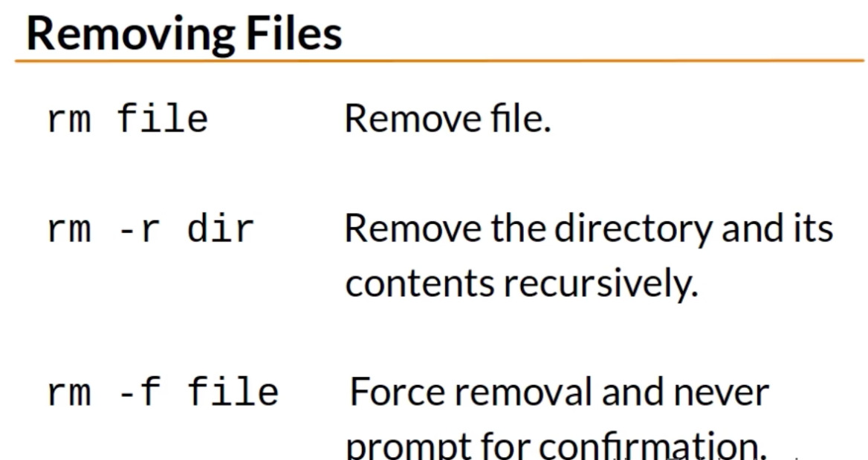

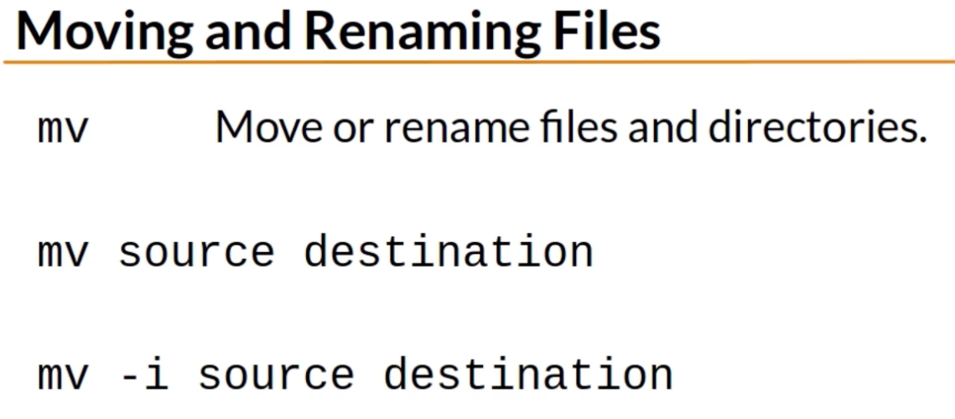

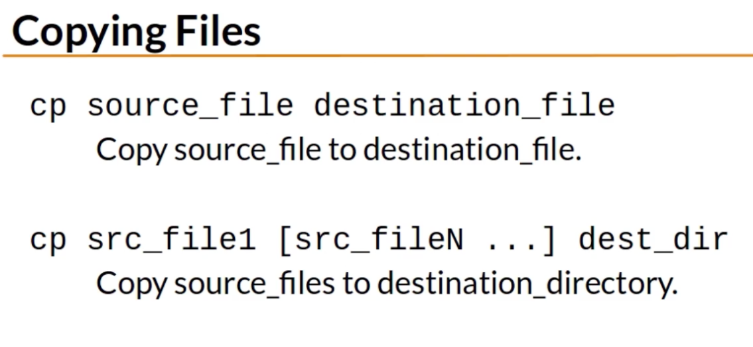

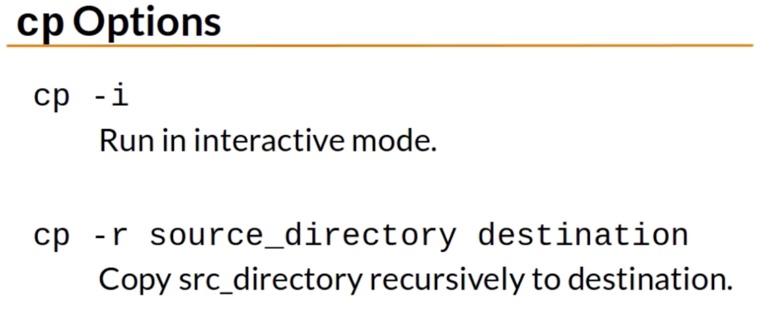

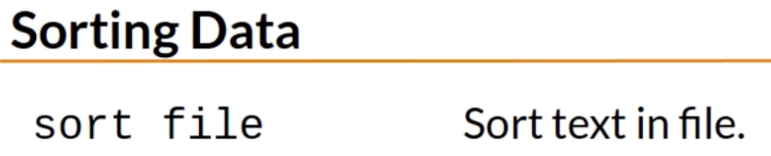

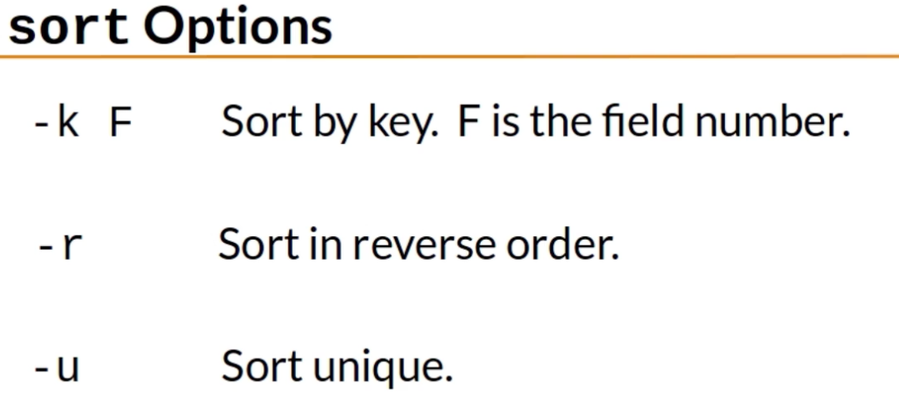

gzcat and zcat serve for viewing the contents of compressed files

